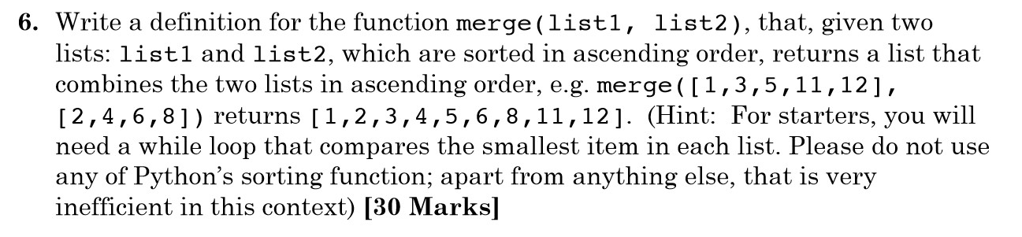

3 ways to do it

Premise: you cannot use sort function

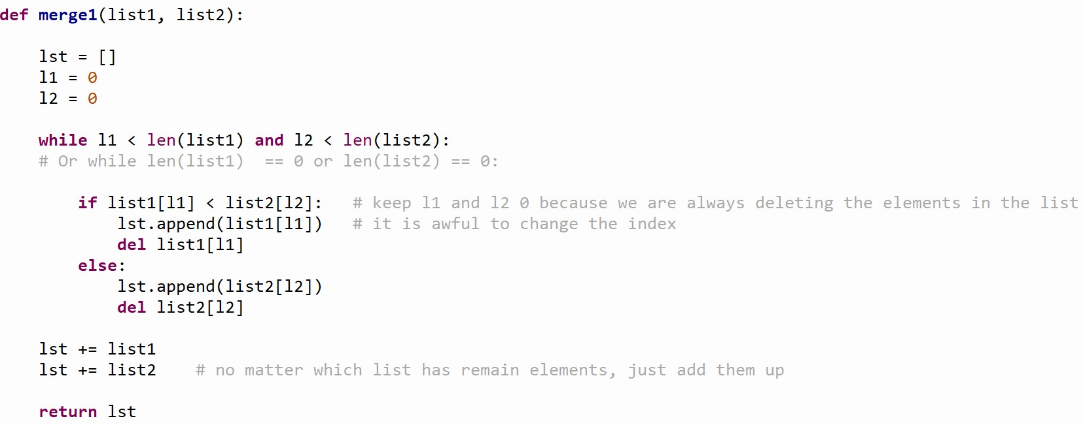

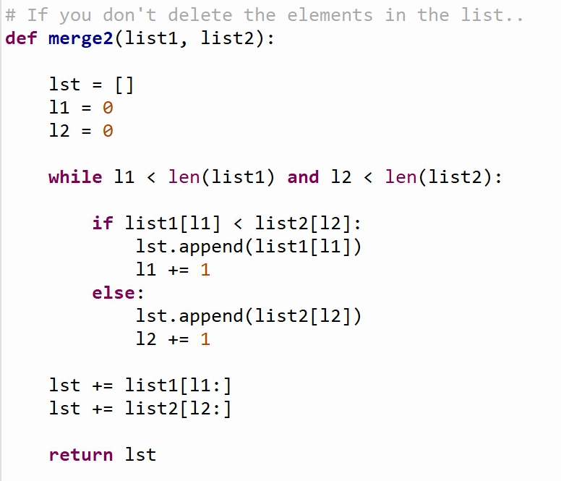

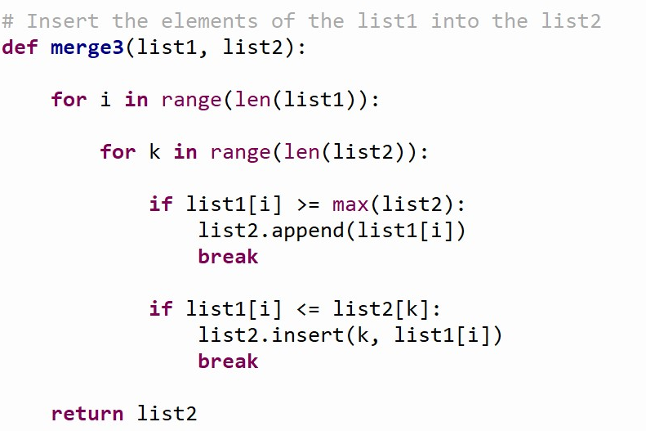

If the length of the list is about to change, you should assign the length to a variable first, so it won’t show any error.